Bare Infinitive as a Verb Complement

✅ What Is a Bare Infinitive as a Verb Complement?
# Source: AI Source: Provided by: [Data Path: Persons Table -> ID Column: 1, Name_En Column: Motasem Essam] -> From: [ChatGPT] on [8/4/2025]
A bare infinitive is the base form of a verb without “to”. It acts as a verb complement after certain verbs and verb constructions—especially causative, perception, and helping verbs.

🔸 Structure:
# Source: AI Source: Provided by: [Data Path: Persons Table -> ID Column: 1, Name_En Column: Motasem Essam] -> From: [ChatGPT] on [8/4/2025]
- Base verb without “to”
- Follows verbs like: make, let, help, see, hear, feel, watch, etc.

🔸 Examples:
# Source: AI Source: Provided by: [Data Path: Persons Table -> ID Column: 1, Name_En Column: Motasem Essam] -> From: [ChatGPT] on [8/4/2025]
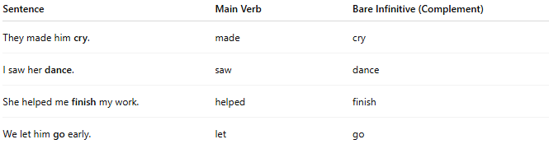
Sentence | Main Verb | Bare Infinitive (Complement)
They made him cry. | made | cry
I saw her dance. | saw | dance
She helped me finish my work. | helped | finish
We let him go early. | let | go

🔸 Why It's a Verb Complement:
# Source: AI Source: Provided by: [Data Path: Persons Table -> ID Column: 1, Name_En Column: Motasem Essam] -> From: [ChatGPT] on [8/4/2025]
Because the bare infinitive completes the meaning of the main verb and often indicates what action is being caused, permitted, perceived, or assisted.
🟢 Example:
- ✅ "They made him cry." (complete)
- ❌ "They made him." (unclear – what did they make him do?)

